Scanario Based Questions
1. Single Inheritance – Vehicle and Car
a. How would you implement this using single inheritance?
- Create a parent class Vehicle with startEngine() and stopEngine().
- Create a child class Car that extends Vehicle.
- Override startEngine() in Car to log the engine start time, then call the parent method.
b.Should Car override startEngine()? Why?
Yes.
Because the car needs additional functionality (logging the start time) while keeping the original engine-start behavior.
c.How can the parent class implementation still be executed?
Use the super keyword.
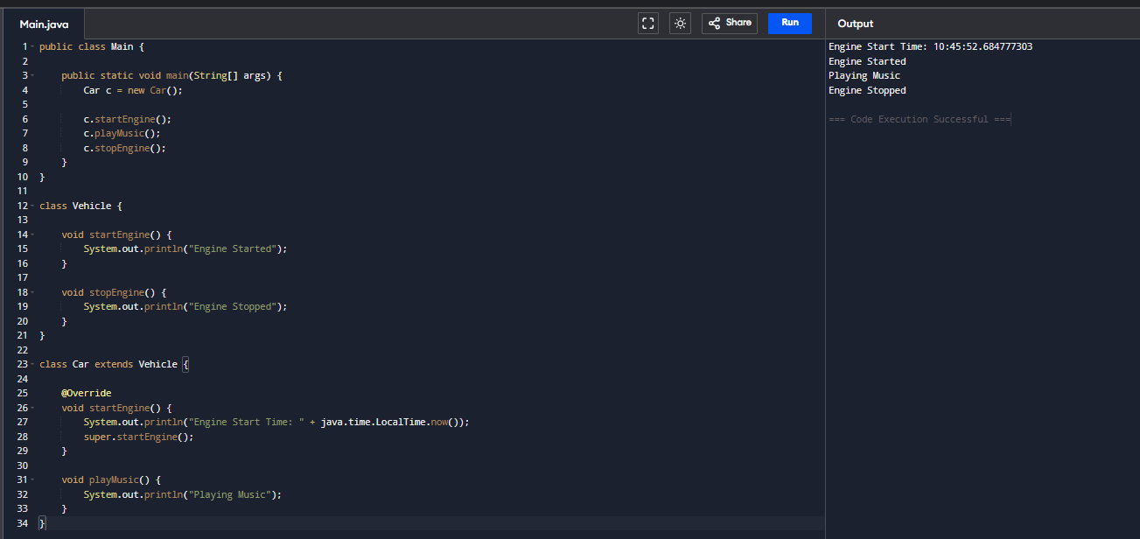
d.What happens if Car does not override startEngine()?
- Car will inherit the startEngine() method from Vehicle.
- No engine start time will be logged.
2. Multilevel Inheritance – Employee
a.Why is multilevel inheritance suitable here?
Because each level adds new features:
- Employee → Employee details
- Developer → Programming language
- SeniorDeveloper → Team size and code reviews
b.Which members are accessible in SeniorDeveloper?
SeniorDeveloper can access:
- Employee ID
- Employee Name
- Programming Language
- Team Size
- Code Review method
- Any public/protected methods from Employee and Developer
c. If Developer overrides a method from Employee, which implementation will SeniorDeveloper inherit?
SeniorDeveloper inherits the Developer's overridden version unless it overrides the method again.
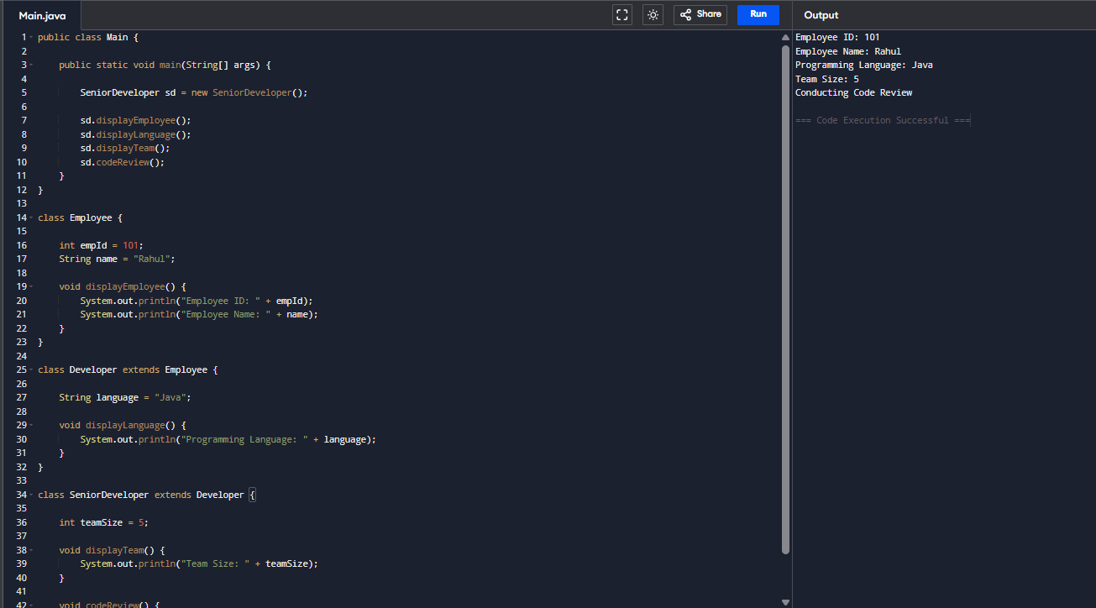
d.Inheritance Hierarchy
Employee
▼
Developer
▼
SeniorDeveloper
3. Hierarchical Inheritance – Payment
a. Why is hierarchical inheritance appropriate here?
Because multiple payment types share common features but have different transaction processing methods.
b. Where should common validation logic be implemented?
In the Payment base class.
Example:
void validatePayment() {
System.out.println("Payment Validated");
}
c. How can each payment class provide its own transaction processing?
By overriding a method such as:
processPayment()
Each subclass implements its own logic.
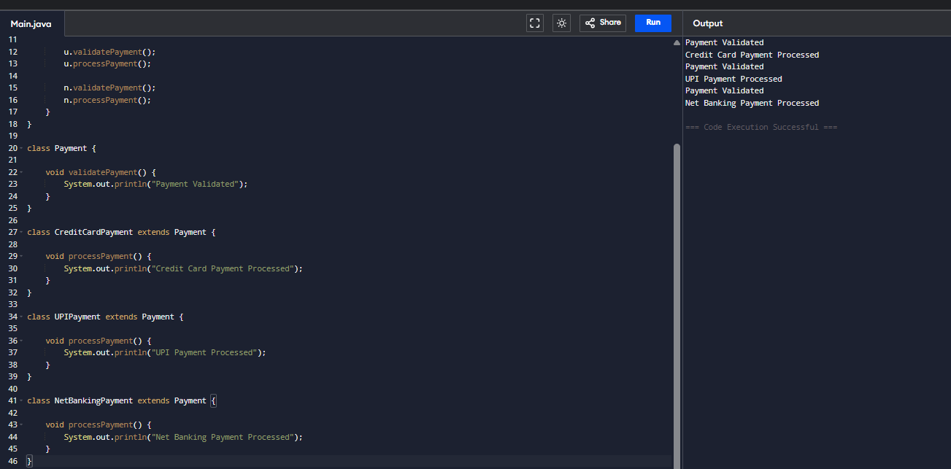
d. What is the advantage over writing three independent classes?
- Code reuse
- Less duplication
- Easier maintenance
- Common validation in one place
- Better scalability
4. Compile-Time Polymorphism (Method Overloading)
a. Which OOP concept should be used?
Method Overloading (Compile-Time Polymorphism).
Example:
add(int a, int b)
add(int a, int b, int c)
add(double a, double b)
b. How will Java decide which method to invoke?
Java selects the method based on:
- Number of parameters
- Type of parameters
- Order of parameters
This decision is made at compile time.
c. Can methods be overloaded by changing only the return type?
No.
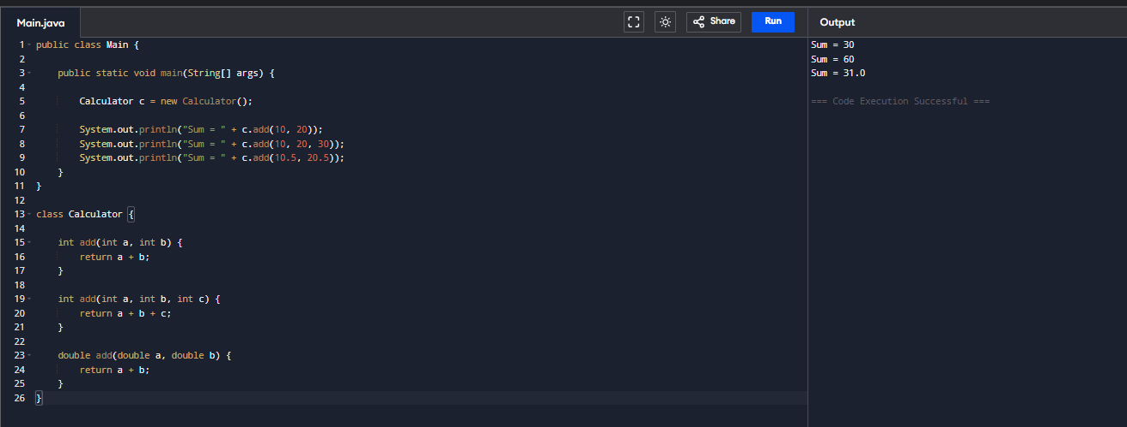
d. What happens if add(5, 10.0) is called?
Java calls:
add(double, double)
because the int value 5 is automatically promoted to double.
5. Runtime Polymorphism (Method Overriding)
a. Which OOP concept is being used?
Runtime Polymorphism (Method Overriding).
b. Which version of calculateDeliveryTime() executes?
The version belonging to the actual object.
Example:
- Pizza object → Pizza's method
- Burger object → Burger's method
- Biryani object → Biryani's method
c. When is the method selection decided?
At runtime, based on the object's actual type.
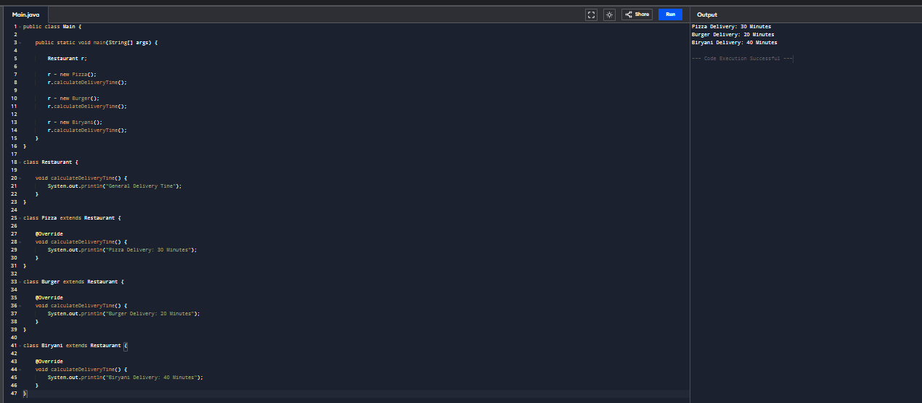
d. What would happen if calculateDeliveryTime() were declared static?
Static methods cannot be overridden.
The method call would depend on the reference type, not the object type, so runtime polymorphism would not occur.
6. Interface – Smart Home Devices
a. Would you use an interface or inheritance? Why?
Use an interface.
Reason:
- Different devices perform the same operations (turnOn(), turnOff()) in different ways.
- New devices can be added without changing existing code.
b. Design an appropriate interface.
interface SmartDevice {
void turnOn();
void turnOff();
}
c. Can one device implement multiple interfaces? Give an example.
Yes.
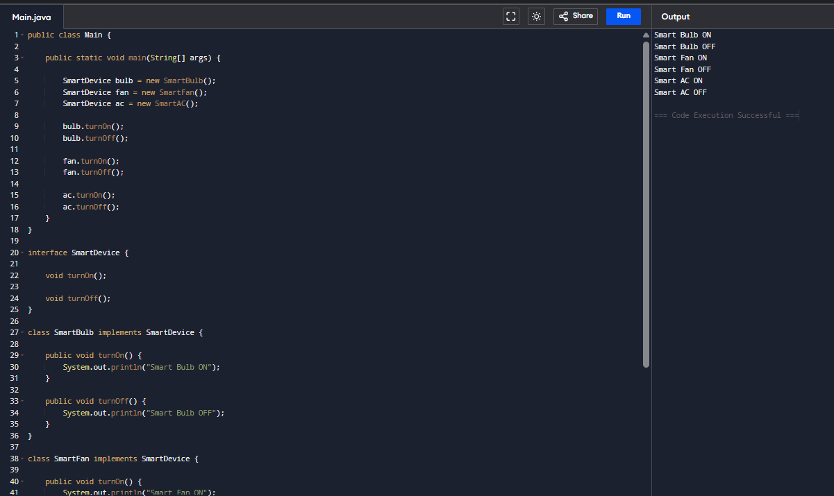
d. Why is an interface better than creating a common base class in this scenario?
- Supports multiple inheritance of behavior.
- Different manufacturers can implement the interface independently.
- Promotes loose coupling.
- Easier to extend with new device types.
- More flexible than forcing all devices to inherit from one base class.

